How to amend via Amend Booking?
In DOTWConnect, we have an option to do an online booking amendment through the DOTWConnect system. This functionality can be used for bookings that are taken from DIRECT CONTRACTS WITH A HOTEL or DMC/LOCAL SUPPLIER.

For bookings that are taken from DYNAMIC, THIRD PARTY or CHANNEL MANAGER booking channels, these needs to be manually amended with the hotel. After, the pre-travel bookings can be updated in DOTWConnect through the Amend Offline functionalities.

HOW TO DO AN ONLINE BOOKING AMENDMENT?

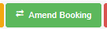
To do an online booking amendment, you would need to click the Amend Booking action button in the lowest part of the page. This button may no longer be available for any amendment request post-amendment deadline. However, provided it is a pre-travel booking and the VCC is not fully loaded, the Amend Offline functionality may still be available.

WHAT CAN WE AMEND VIA THE AMEND BOOKING WORKFLOW?

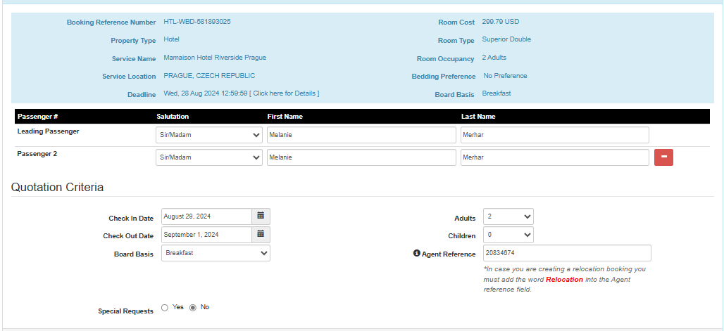

The amendment functionality will give you the booking summary on top, as well as the amendment options available for the booking. Please make sure to take note of the selling price, in the ROOM COST row in the top right, as you will need this to manually calculate the additional selling price the customer needs to pay for the amendment.

For online amendments, these includes the ability to do:

1. Name Amendments/Correction
2. Date Amendments
3. Occupancy Amendments
4. Meal Plan Amendments: These are limited to the available meal plans to the contract. If the meal plan is not available, you would need to coordinate with the hotel and process the amendment via Amend Offline.

CAN WE INPUT SPECIAL REQUEST THROUGH THE AMEND BOOKING WORKFLOW?
The Online Booking Amendment will give a tick-box to choose special requests. However, encoding the special requests through this functionality may end up re-calculating the booking on its current selling price, charging the customer/client higher. Due to this, special requests for DOTWConnect bookings need to be manually sent to the hotel/supplier via email or phone.

HOW TO CALCULATE THE ADDITIONAL SELLING PRICE FOR THE AMENDMENT?
Once you have done the necessary amendments the customer is requesting, you can click on the "Proceed with the Amendment" button. It will then give you a quotation of the available rates, for the amendment the customer is requesting.

Make sure to go through with the rate plan quotations thoroughly, as the rate plan quotations can differ either on the new cancellation deadlines or the new total selling price.

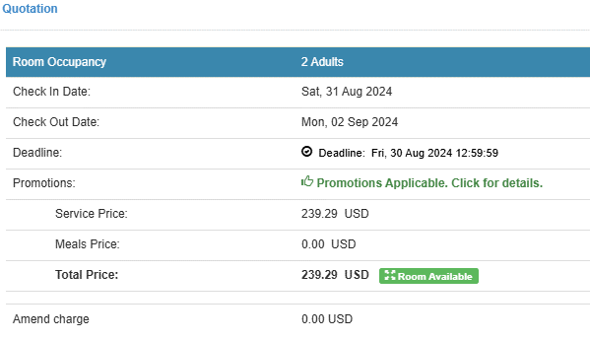

For example, if the customer would choose the rate plan above, the cancellation deadline will change to "Within Deadline," which means that cancellation or amendment charges will already apply for any further changes/cancellation after. In addition, the new total price is higher by USD 122.89 after the amendment, compared to the original selling price.

Lastly, when offering a rate plan to a customer/client, make sure that the status shows "Room Available." This will ensure that if the customer chooses this rate plan, the allocation and room is indeed available with the hotel.

If the rate plan's status shows "Room on Request," make sure to check first with the hotel if the room or rate is still available. A Room on Request status would mean that the room is either already above allocation or sold out.

HOW TO FINALIZE THE BOOKING AMENDMENT?
Before proceeding and confirming the amendment in the system, please review the change and advice the customer/client the:

A. Additional Selling Price to change (New Total Selling Price minus Original Room Cost/Selling Price);
B. Any Amendment Penalty,
C. New Cancellation Deadline for the Rate Plan and
D. New Booking Details.

If the customer/client agrees with the changes, and more importantly the additional rate to change, you may proceed to amend the booking and confirm the amendment the customer requested.

If a booking is payable via Virtual Credit Card, the customer invoice and the VCC information and amount will automatically be updated once the amendment is completed in the system. Similarly, if a booking is payable via monthly invoicing, the invoices for the supplier and client will automatically be updated, as well.

